**LAPORAN PRAKTIKUM 3  
ACTIVITY DAN INTENT**

**NPM : 23.22.2515**

**Nama : Meisha Afifah Putri**

Bahan : Modul Praktikum 3 – Acitivity dan Intent

Alat : Android Studio

**Desain Halaman Login**

Source code layout :

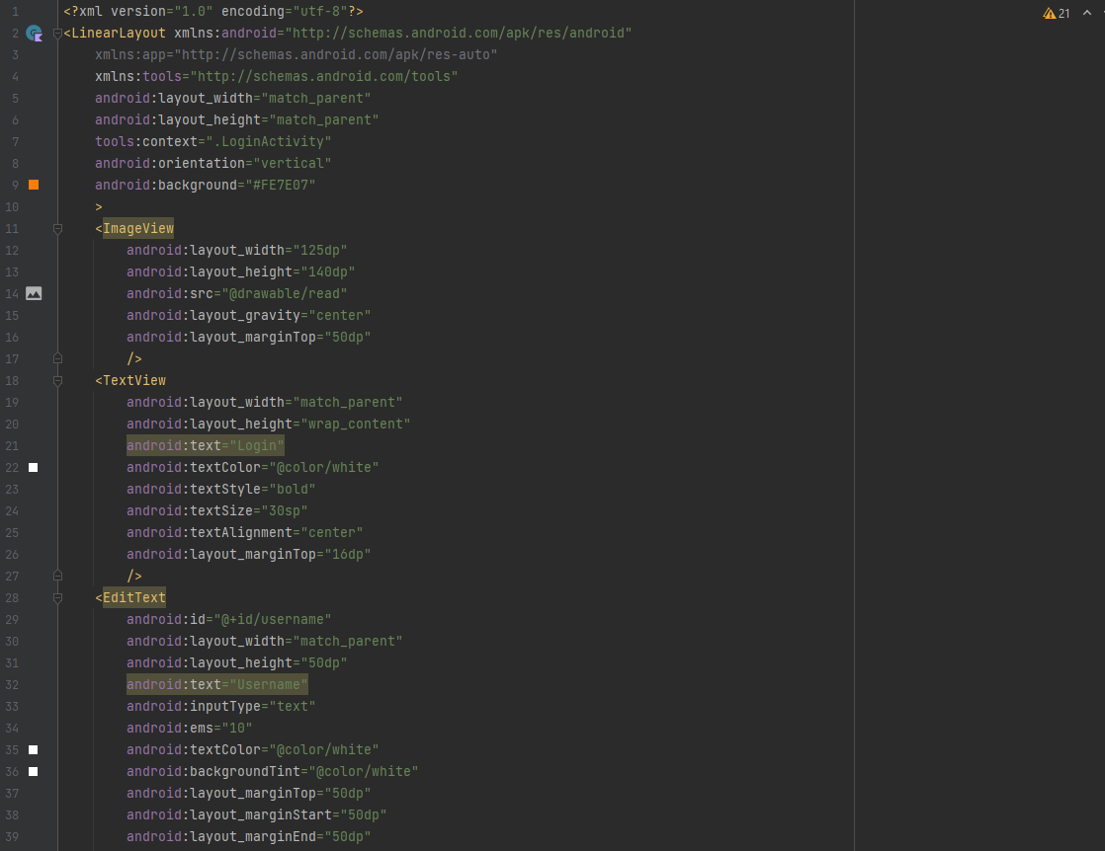

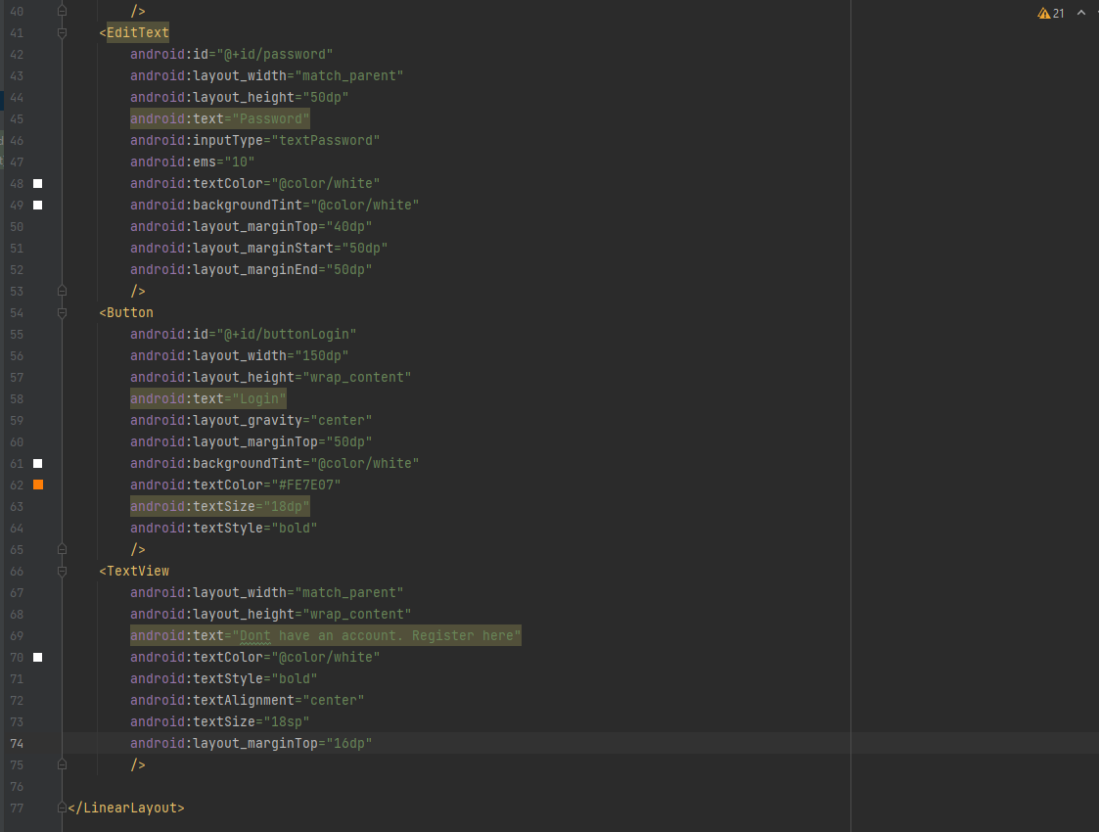

Design UI :

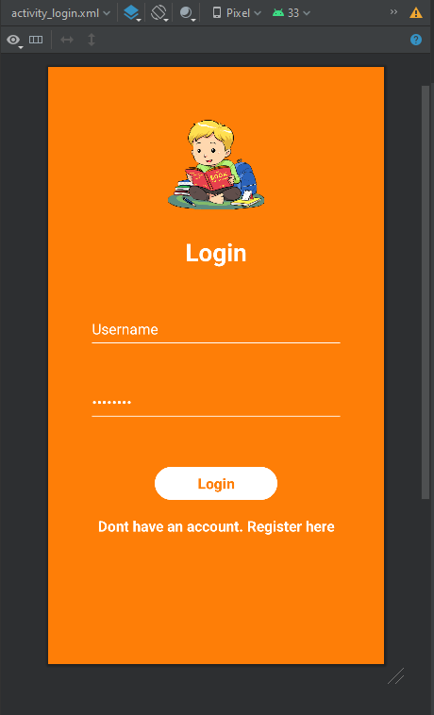

**Desain Halaman About Us**

Source code layout :

Design UI :

**EXPLICIT INTENT**

1. Menampilkan Activity Home (home page) dari Activity Login

|  |  |
| --- | --- |
|  |  |
|  |  |

1. Menampilkan Activity About dari Activity Home

|  |  |
| --- | --- |
|  |  |

**IMPLICIT INTENT**

1. Dial Number

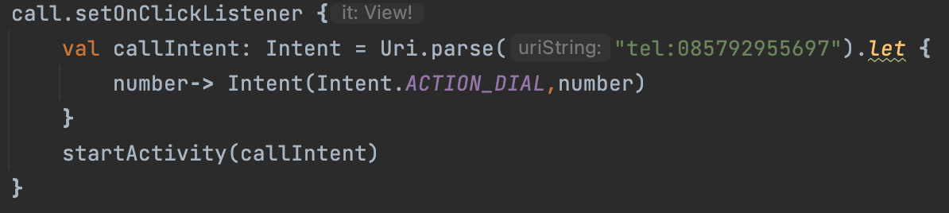

1. Web Browser

1. Google Maps

